Tracking Project: Factors Affecting the Amount of Sleep in a Day
Name
Institution of Affiliation
Tracking Project: Factors Affecting the Amount of Sleep in a Day
Lab 2: Sample Study Results
There are many factors, both internal and external, that can influence the quantity and quality of the sleep we obtain. Often people who experience sleep issues overlook relatively simple factors that may be causing them to miss out on the sleep they need. A variety of internal and external factors can dramatically influence the balance of this sleep-wake system. Research has shown that the number of hours that an individual sleep in a day are influenced by a variety of factors. Some of these factors include stress, amount of food taken, and individual’s mood among others. This research seeks to establish the factors that affect my sleep schedule as well as the average amount of sleep I get every 24 hours. The three measurements used include the number of hours I sleep in a day including naps, my mood for the day on 1-5 scale, and the amount of food I eat in a day measured in terms of calories. The independent variables are the mood for the day and the amount of food while the dependent variable is the number of sleep hours in a day.
The hours of sleep were measured as nominal numbers with zero decimal numbers while the mood was measured as an ordinal variable with the different levels being ordered into categories; 1 signified a relaxed or calm mood, 2 signified an ok mood, 3 signified a nervous mood, 4 signified an angry mood, and 5 signified a mood where one was going to explode. Each of these levels of mood were expected to influence the number of hours that I was going to sleep. The food amount was measured in calories. So far I have 20 observations recorded over a period of 20 days and the way they appear in the SPSS data view is shown in figure 1 below.
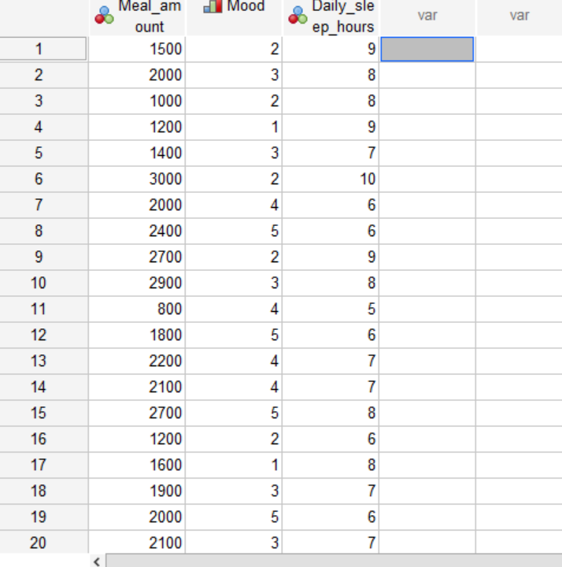
Figure 1: Appearance of the observations in the SPSS data view
The variable to be described is the amount of sleep measured in hours because it is the one being impacted by the two independent variables. The measures of central tendency and dispersion for the variable is shown in table 1 below based on the output of SPSS analysis. The mean is 7.35 while the median is 7.00 and the mode is 6. It has been indicated that multiple modes exist and only the smallest one has been recorded. The mean and the median are not significantly part meaning that most of the values are found towards the middle and the standard deviation from the sample mean is 1.309 with a minimum value of 5 hours and a maximum value of 10 hours. The 95% confidence interval for the mean is denoted 6.674 for the lower limit and 7.96 for the upper limit. The frequency distribution of the amount sleep in terms of hours is shown in figure 2.
Table 1: measures of central tendency and dispersion
 |  |  | Statistic | Std. Error
Hours | Mean |  | 7.35 | .293
Hours | 95% Confidence Interval for Mean | Lower Bound | 6.74
Hours | 95% Confidence Interval for Mean | Upper Bound | 7.96
Hours | 5% Trimmed Mean |  | 7.33
Hours | Median |  | 7.00
Hours | Variance |  | 1.713
Hours | Std. Deviation |  | 1.309
Hours | Minimum |  | 5
Hours | Maximum |  | 10
Hours | Range |  | 5
Hours | Interquartile Range |  | 2
Hours | Skewness |  | .208 | .512
Hours | Kurtosis |  | -.595 | .992

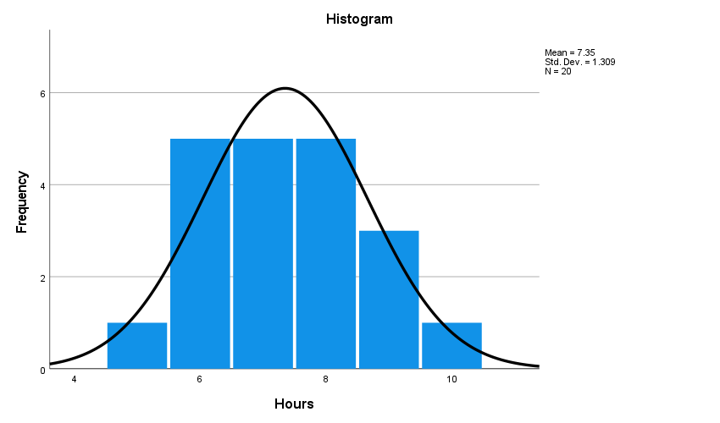
Figure 2: Frequency distribution of the number of sleep hours.

Reflecting on the average sleep hours I get daily, the results match my expectations. I barely sleep past 7 hours in a day. I believe the sample observations are a representation of my sleep amount with the various fluctuations affected by the various factors such as the mood and food amount.
Lab 3: Measurement Assessment
In choosing the measurements for the tracking project, I knew mood is a categorical variable and could be evaluated using adjectives describing the different levels. This levels could then be placed on a scale with the various classes being assigned a value from 1 to 5. food amount was operationalized in terms of daily calorie intake, which could then be measured as a continuous variable. Sleep amount was presented in terms of hours per day, thereby making it possible to be measured as a continuous variable.
The measurements I chose are the most appropriate in terms of reliability and validity. Only the mood variable required recording so that it could be measurable. The observations for variable were recorded in text format and since the data was ordinal, the various responses were assigned different values to enable analysis. Amount of sleep in hours is appropriate for analysis and did not need more recording. Besides, measuring food intake in terms of calories was the most appropriate to create harmonized values regardless of the food type.
The variables in the project could not have operationalized differently. No better different units of analysis could be used. However, for the mood variable, different adjectives that describe mood could be used and the scale could be expanded to be 1-10. This alternative would complicate the analysis part. Besides, the food amount can also be measured in terms of pounds. However, this alternative would be less accurate because different food types have distinctive impact on the individual regardless of the kilograms consumed. The harmonized way to operationalize the variable is to use calories.
Lab 4: Observational Study Results
So far there are 30 observations recorded within a period of 30 days. As I continue to add more data, the more reliable and valid the results from the analysis will be. The first null hypothesis is that the amount of food eaten does not affect the sleep amount. The prediction is that average daily sleep will not be significantly affected by the amount of food eaten. The second null hypothesis is that the mood of an individual does not significantly affect their sleep amount. The prediction is that the amount of sleep will be the same regardless of the mood of the individual. The third hypothesis is that the combined effect of the two variables, mood and amount of food eaten does not significantly affect the amount of sleep.
Results from the SPSS output shows that the interaction effect of the two independent variables with the dependent variable has a significant level (.489) that is above the alpha value (.05). Therefore, we accept the null hypothesis that there is no statistically significant effect of the interaction of mood and amount of food with the amount of sleep. The significance level of the main effect of mood is 0.017, which makes it statistically significant. Therefore, I reject the null hypothesis that the effect of mood on sleep amount is not statistically significant. The significance level of the main effect of amount of food is 0.017, which is also statistically significant. Hence, the null hypothesis that the effect of amount of food eaten on the sleep amount is not statistically significant. These results are presented in table 2 below.
Table 2: analysis of the main and interactive effect of mood and amount of food eaten on Sleep amount
Tests of Between-Subjects Effects
Dependent Variable: Hours
Source | Type III Sum of Squares | df | Mean Square | F | Sig.
Corrected Model | 71.633ª | 24 | 2.985 | 12.792 | .005
Intercept | 1447.128 | 1 | 1447.128 | 6201.978 | .000
Meal_amount | 30.071 | 17 | 1.769 | 7.581 | .017
Mood | 8.333 | 4 | 2.083 | 8.929 | .017
Meal_amount * Mood | .654 | 3 | .218 | .934 | .489
Error | 1.167 | 5 | .233
Total | 1898.000 | 30
Corrected Total | 72.800 | 29
a. R Squared = .984 (Adjusted R Squared = .907)

It is evident that only one of my predictions was correct. The combined effect of mood and amount of food eaten on the sleep amount is not statistically significant. However, the other two predictions were incorrect. Both the main effect of mood and amount of food taken on the sleep amount were statistically significantly; there significance level were below the alpha value (.05).
Lab 6: Quasi-Experimental Study Results
In this experiment, the amount of food taken was not random but it was intentionally regulated to increase gradually over the days while the mood was kept constant at “ok”. The calories amount had a difference of 200 with the least amount being 800 and highest being 4600. The effect of this controlled food intake on the food amount was then evaluated using correlation analysis. The results of the analysis are shown in table 3 below. This was the appropriate approach because the two variables were nominal. For constant food intake, the impact of various mood levels on the sleep amount was also evaluated and the results shown in table 4.
Table 3: Correlation analysis between amount of food taken and Sleep hours.
 |  | Food_amount | Sleep_hours
Food_amount | Pearson Correlation | 1 | .973**
Food_amount | Sig. (2-tailed) |  | .000
Food_amount | N | 20 | 20
Sleep_hours | Pearson Correlation | .973** | 1
Sleep_hours | Sig. (2-tailed) | .000
Sleep_hours | N | 20 | 20
**. Correlation is significant at the 0.01 level (2-tailed).

Based on the analysis above, it is evident that the two variable have a strong positive correlation of .973 when a .01 significant level is used. Therefore, it can be concluded that the amount of food taken (calories) has a strong effect on the average daily sleep hours.

Table 4: correlation analysis between mood and sleep hours.
 |  | Mood | Sleep_amount
Mood | Pearson Correlation | 1 | -.882**
Mood | Sig. (2-tailed) |  | .000
Mood | N | 20 | 20
Sleep_amount | Pearson Correlation | -.882** | 1
Sleep_amount | Sig. (2-tailed) | .000
Sleep_amount | N | 20 | 20
**. Correlation is significant at the 0.01 level (2-tailed).

Mood and sleep hours have a strong negative correlation of -.882. As the mood becomes worse, an individual is unable to sleep for more hours.
It is evident that the amount of food eaten have a more significant correlation with the sleep amount than the mood of the individual. The threats to the validity of the experiment include testing and John Henry effect. The threats of testing entail the effects of taking the test on the outcomes of taking a second test. John Henry was a worker who outperformed a machine under an experimental setting because he was aware that his performance was compared with that of a machine (Ohlund & Yu, n.d.). The limitations of the study include the inability to include other factors that could affect the amount of sleep, such as health, presence of stress and work schedules. If I would do the study again I would reduce the scale of mood responses to make them two, which would simplify the analysis process.

References
Healthy Sleep. Med. (n.d.). External Factors that Influence Sleep. Retrieved from http://healthysleep.med.harvard.edu/healthy/science/how/external-factors
Ohlund, B. & Yu, C. (n.d.). Threats to validity of Research Design. Retrieved from https://web.pdx.edu/~stipakb/download/PA555/ResearchDesign.html

